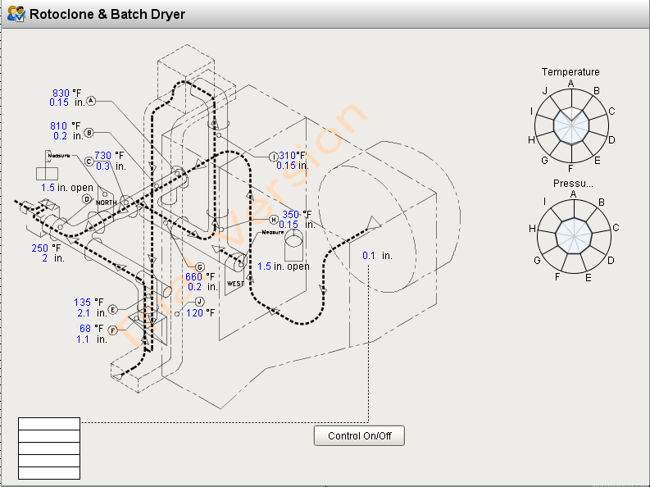Stage 1 Expanded Proposal

The Dryer/Rotoclone system, as originally designed, is intended to perform three process-critical tasks:

1. Provide a controllable negative-pressure environment at the back end of the rotary kiln for hot zone control.
2. Use waste process heat to preheat and dry clinker before it hits the rotary kiln – preventing clinker explosions in the kiln, as well as increasing heat efficiency. Maintain manual supervisory control of the drying process.
3. Reduce environmental dust emissions from process through dust collection.

Each task is critical to the process, while only the last is occurring reliably with a fair degree of certainty.

**Task 1 - Back-end pressure control:**

**Intended operation:**

There is a pneumatic controller, affectionately known as ‘Smiling Jack,’ stationed near the dusthouse. Smiling Jack is supposed to read the pressure near the back end of the kiln, compare that pressure to environmental pressure, and then make adjustments to a dust house ‘damper’ vent which will either increase or decrease the pressure by closing or opening the vent, respectively.

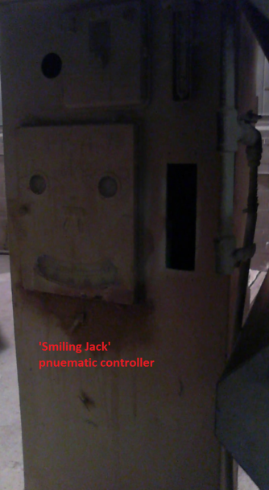 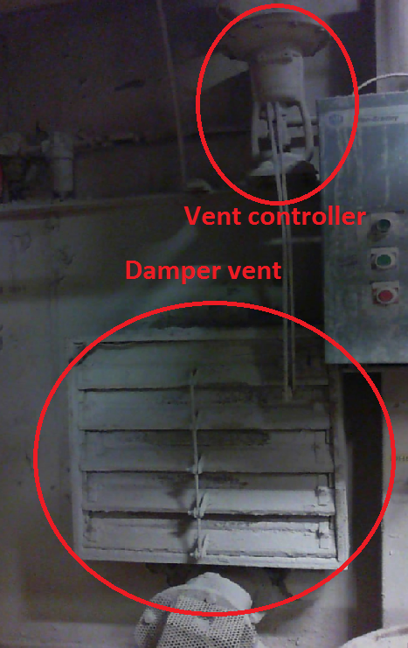

Actuator

**Major problems with system:**

1. Smiling Jack is 50 years old, and may or may not work.
2. Support for pneumatic controllers no longer exists.
3. The pressure measurement point inside the dust house has been bricked over at some point, so we are no longer properly measuring pressure inside the system.
4. The vent is old and worn, and no longer seals as well as it could.

**Current Solution:**

In lieu of a proper pressure control system, we have opted to let operators and supervisors manually control the position of the damper vent. We have gone as far as incorporating the manual operation into our SPPC. Some major drawbacks of this approach are:

1. Control of pressure only when manually supervised
2. Guess-and-check methodology applied to control (based on system temperature instead of pressure)
3. Improper adjustment of flame train and/or dryer slide gates to adjust for improper control of the damper.

**Project resolution proposal:**

1. Replace ‘Smiling Jack’ with a Honeywell HC900 controller (as selected by controls group: John Ataman, Eric Van Horn, Bobby Miller).
2. Purchase a pressure reading instrument for the dusthouse.
3. Cut existing dusthouse pressure line, drill a tap through the brick, and then replace the line with new fittings.
4. Build control program for new system (with documentation and training to controls group).
5. Evaluate replacing vent and/or actuator.

**Task 2 – Clinker Dryer System monitoring and control**

**Intended operation:**

There are ten points of temperature and pressure data acquisition throughout the dryer/rotoclone system, which have historically been manually recorded by operations, and reviewed by supervision, to ensure proper drying and heating through the product conveyor. After review, adjustments could be made to two slide gate valves: the ‘west’ gate and the ‘north’ gate. The former gate acts as an atmospheric-make-up valve, cooling the air stream. The latter acts as a process bypass, adding or removing process heat to/from the dryer. Historically, the goal has been to maintain close-to-setpoint temperature and pressure reading outputs from the gauges. I have little context for the setpoint decisions.

**Major problems with the system:**

1. Eight of the ten temperature probes do not work.
2. The review process has been lost through turnover.
3. Many of the gauges are placed in awkward locations, which makes recording difficult and uncomfortable during the summer.

**Current solution:**

Because we have lost the process of reviewing the gauge data and making informed decisions, we have opted to make the ‘north’ gate constant – unchanging. The ‘west’ gate is modified through a guess-and-check process by operators or supervision.

**Project resolution proposal:**

1. Replace the manual gauges with digital transducers.
2. Record and store process data with the new instruments
3. Use process data and experimentation to understand process change effects.
4. Potentially incorporate the west and north gates into a control scheme to automatically control the drying process.